

**User Manual**

**SiLabs Door Lock Application**

|  |  |
| --- | --- |
| **Version**  **Status**  **Date** | 0.5  Draft  09-Sept-2020 |

**Confidentiality Notice**

Copyright (c) 2020 eInfochips. - All rights reserved

This document is authored by eInfochips and is eInfochips intellectual property, including the copyrights in all countries in the world. This document is provided under a license to use only with all other rights, including ownership rights, being retained by eInfochips. This file may not be distributed, copied, or reproduced in any manner, electronic or otherwise, without the express written consent of eInfochips.

Contents

1 Document Details 6

1.1 Document History 6

1.2 Definition, Acronyms and Abbreviations 7

1.3 References 8

2 Hardware required 9

2.1 Hardware Interface Diagram 9

3 Power Requirement 10

4 EFR DEVICE SET UP 11

4.1 EFR Set Up with Fingerprint Sensor 12

4.2 EFR Set Up with Keypad Module 14

4.3 EFR Set Up with Face Recognition Module 15

4.4 EFR Set Up with LED Module 16

4.5 Door Lock Zigbee Set Up with Switch 17

5 Software required 18

5.1 Simplicity Studio 18

5.1.1 Step for importing workspace in Simplicity Studio is given below 18

5.1.2 Steps to update the build path 20

5.1.3 Steps to build the application 22

5.1.4 Steps to upload the application 23

6 Operating the Demo 26

6.1 General Operation 26

6.2 Enrolling an User 26

6.2.1 Enrolling a Keypad Value 26

6.2.2 Enrolling a Fingerprint 26

6.2.3 Enrolling a Face 26

6.3 Authenticating a User 27

6.3.1 Single-Factor Authentication: Keypad 27

6.3.2 Single-Factor Authentication: Fingerprint 27

6.3.3 Single-Factor Authentication: Face 27

6.3.4 Two -Factor Authentication: Keypad + Fingerprint 28

6.3.5 Two -Factor Authentication: Keypad + Face 28

7 Known Issues 29

8 Limitations and constraints 30

9 Appendix 31

9.1 Downloading an IAR Trial License 31

9.2 Datasheets 33

**FIGURES**

Figure 1: Hardware Interface Diagram 9

Figure 2: Top Level EFR32 Door Lock System 10

Figure 3: SLWSTK6006A Interface with R307 Fingerprint Image View 1 11

Figure 4: SLWSTK6006A Interface with R307 Fingerprint Image View 2 12

Figure 5: SLWSTK6006A Interface with R307 Fingerprint Pin Out Diagram 12

Figure 6: SLWSTK6006A Interface with TTP229 Keypad Module Image 13

Figure 7: SLWSTK6006A Interface with TTP229 Keypad Module Pin Out Diagram 13

Figure 8: SLWSTK6006A Interface with Omron B5T Image 14

Figure 9: SLWSTK6006A Interface with Omron B5T Pin Out Diagram 14

Figure 10: SLWSTK6006A Interface with External LED Pin Out Diagram 15

Figure 11: DMP Door Lock Zigbee Setup with Switch 16

**TABLES**

Table 1: Document History 6

Table 2: Definition, Acronyms and Abbreviations 7

Table 3: References 8

# Document Details

## Document History

|  |  |  |  |  |  |  |
| --- | --- | --- | --- | --- | --- | --- |
| **Version** | **Author** | | **Reviewer** | | **Approver** | |
| **Name** | **Date**  **(DD-MM-YYYY)** | **Name** | **Date**  **(DD-MMM-YYYY)** | **Name** | **Date**  **(DD-MM-YYYY)** |
| Draft 0.1 | Manish Thakur,  Hardik Kumar Patel,  Prassana Sakore,  Vipul Kole | 24-08-2020 | Shachi Mahajan |  |  |  |
| Draft 0.2 | Manish Thakur,  Hardik Kumar Patel,  Prassana Sakore,  Vipul Kole | 31-08-2020 | Shachi Mahajan |  |  |  |
| Draft 0.3 | Manish Thakur,  Hardik Kumar Patel,  Prassana Sakore,  Vipul Kole | 04-09-2020 | Ben Klingelhefer |  |  |  |
| Draft 0.4 | Manish Thakur,  Hardik Kumar Patel,  Prassana Sakore,  Vipul Kole | 07-09-2020 | Paul Ferrara, Ben Klingelhefer |  |  |  |
| Draft 0.5 | Paul Ferrara, Hardik Kumar Patel | 09-09-2020 | Ben Klingelhefer |  |  |  |

| **Version** | **Description of Change** |
| --- | --- |
| Draft 0.1 | Created initial draft version |
| Draft 0.2 | Updated pin connection of Omron B5T module |
| Draft 0.3 | Incorporated review comments of Ben |
| Draft 0.4 | Incorporated review comments from ESC and team |
| Draft 0.5 | 1. Updated software import/build/upload steps 2. Added “Operating the Demo” section 3. Added “Appendix 8” for downloading/installing an IAR trial 4. Added build “steps to update the build path” |

Table 1: Document History

## Definition, Acronyms and Abbreviations

|  |  |
| --- | --- |
| Definition/Acronym/Abbreviation | Description |
| SRS | System requirement specification |
| SDD | Software design document |
|  |  |
|  |  |

Table 2: Definition, Acronyms and Abbreviations

## References

|  |  |  |  |
| --- | --- | --- | --- |
| No. | Document | Version | Remarks |
| 1 | ei_SW_TMP_SystemRequirementSpecification_SiLabs_Door_Lock | 1.1 | SRS |
| 2 | ei_SW_TMP_DesignSpecification_SiLabs_Door_Lock | 1.1 | SDD |

Table 3: References

# Hardware required

|  |  |  |  |
| --- | --- | --- | --- |
| **Qty** | **Item** | **Description** | **Link** |
| 1 | SLWSTK6006A Kit | EFR32xG21 Wireless Gecko Starter Kit | [[Arrow](https://www.arrow.com/en/products/slwstk6006a/silicon-labs)] |
| 1 | R307 Fingerprint Module | UART Fingerprint Scanner | [[Sunrom](https://www.sunrom.com/p/finger-print-sensor-r307-new-r305)] |
| 1 | TTP229 | 16-Button Capacitive Touch Sensor Module (I2C) | [[Sunrom](https://www.sunrom.com/p/816-channel-capacitive-touch-module-ttp229)] |
| 1 | Omron B5T | Facial-Recognition Camera (HVC-P2) [[Setup](https://www.youtube.com/embed/3hTRxY-qVXc?rel=0&autoplay=1)] | [[Arrow](https://www.arrow.com/en/products/b5t007001020/omron)] |
| 1 | A06SR06SR30K305B‎ | 12” JST Breakout Cable for CN5 on B5T | [[DigiKey](https://www.digikey.com/products/en?keywords=A06SR06SR30K305B)] |
| 3 | LED Lamp | Visual Process Indication (Red/Green/Solenoid) |  |
| 3 | 1k 1/2W Resistor | Current Set Resistor for LED Lamps |  |

## Hardware Interface Diagram

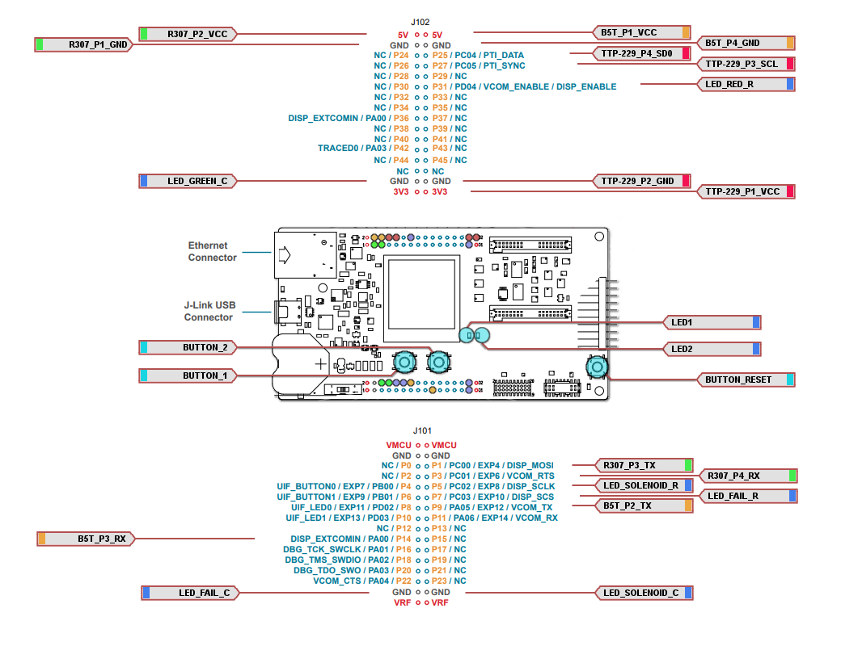

Figure 1: Hardware Interface Diagram

# Power Requirement

**Voltage**: 5V ± 10% (USB)

**Current**: Average (operation, typical) 0.50A, peak 0.85A

**Note1**: USB 3.0 should supply enough current to run the demo from a single USB port, while USB 2.0 will require two ports to deliver adequate current.

**Note2**: Strange behavior can sometimes be related to inadequate or unstable power; when in doubt, break out your components onto multiple 5V sources and check that your wires are large enough for adequate power delivery without appreciable voltage drop

**Note3**: DO NOT power the Omron B5T from the onboard micro-USB port while using the camera in the door lock demo; power must be delivered through the CN5 UART connector, and the USB connector must not be connected to a PC/power source

# EFR DEVICE SET UP

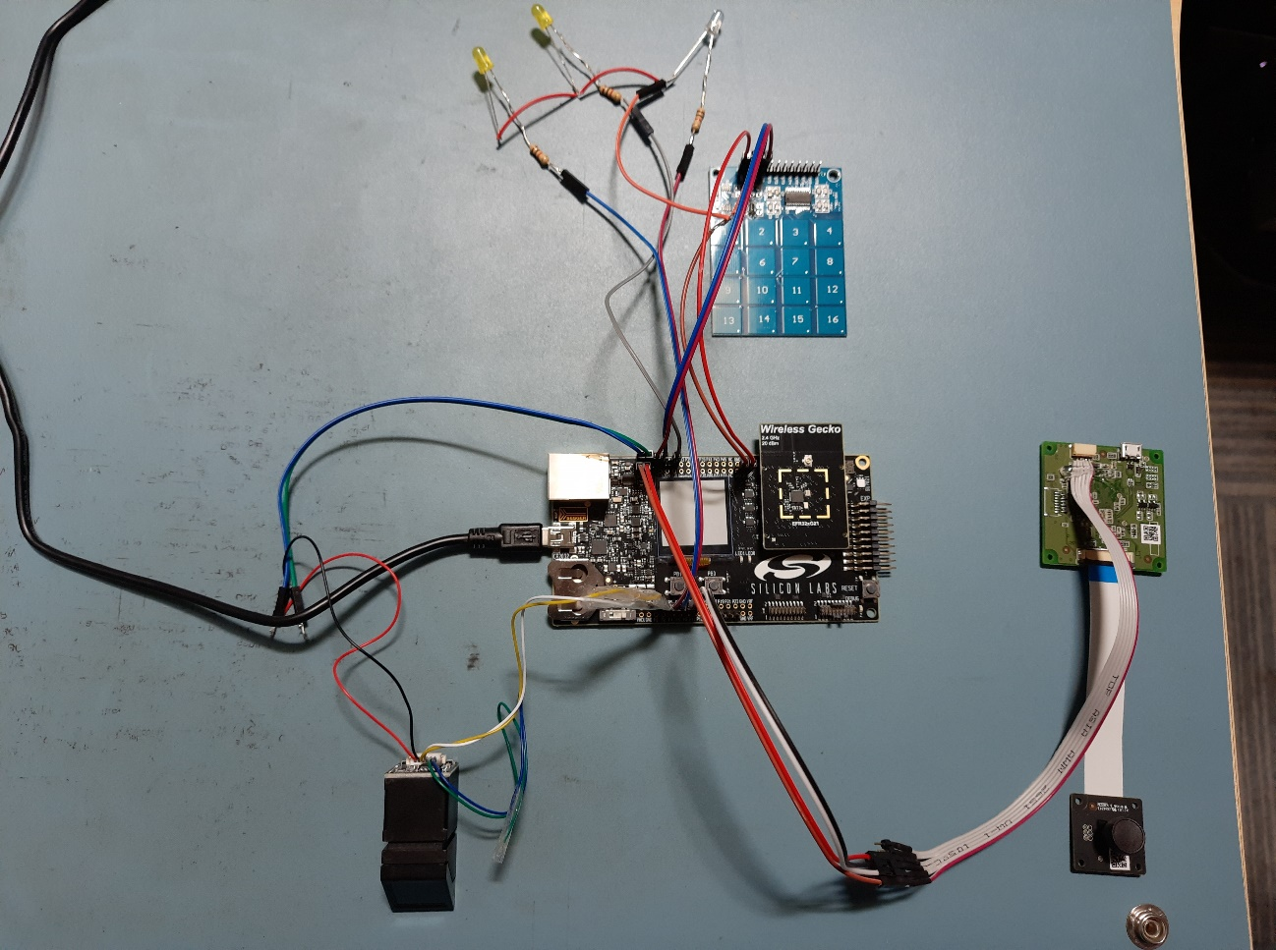

Figure 2: Top Level EFR32 Door Lock System

The above image shows the different modules connected with the EFR32MG21 device.

## EFR Set Up with Fingerprint Sensor

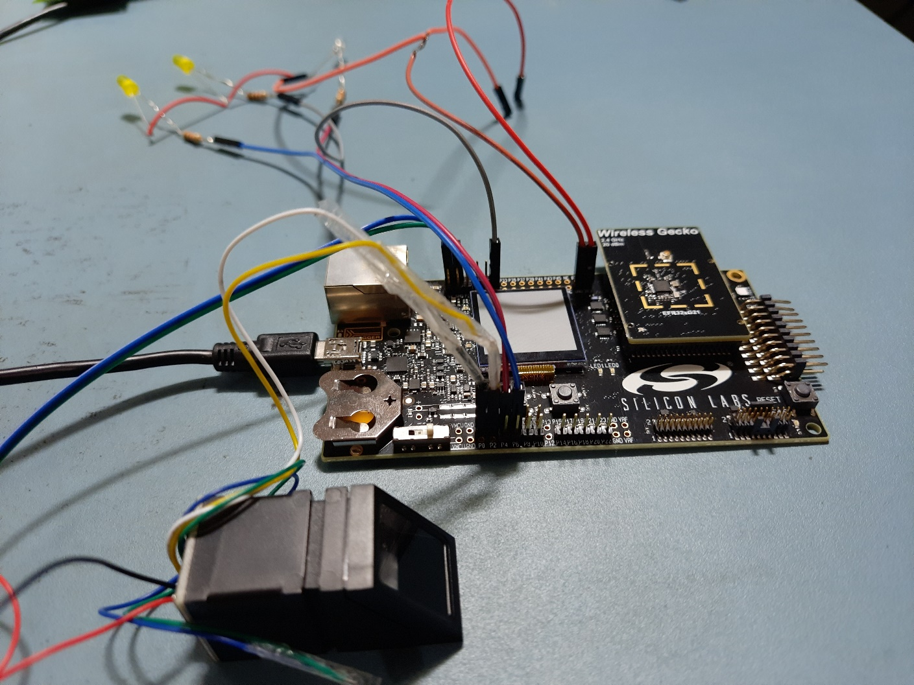

**Figure 3: SLWSTK6006A Interface with R307 Fingerprint Image View 1**

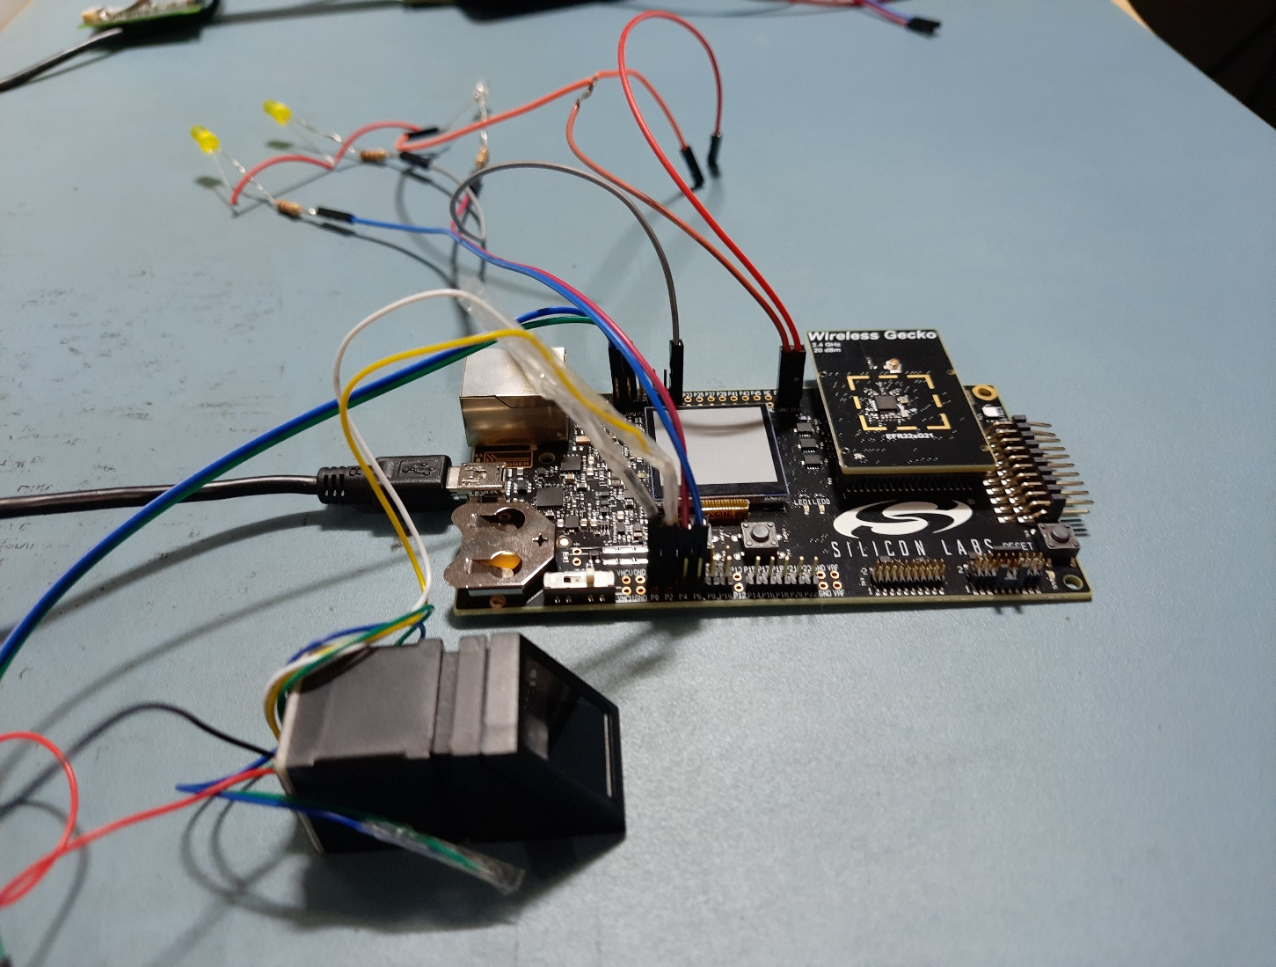

**Figure 4: SLWSTK6006A Interface with R307 Fingerprint Image View 2**

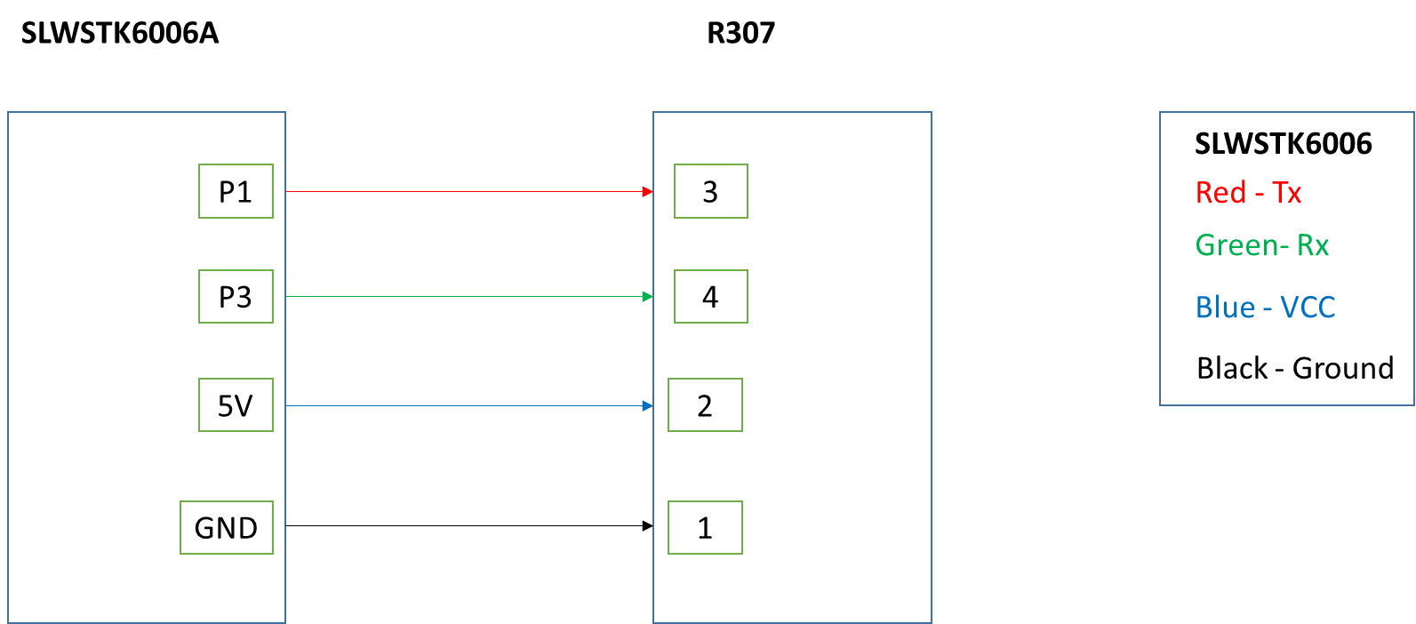

**Figure 5: SLWSTK6006A Interface with R307 Fingerprint Pin Out Diagram**

## EFR Set Up with Keypad Module

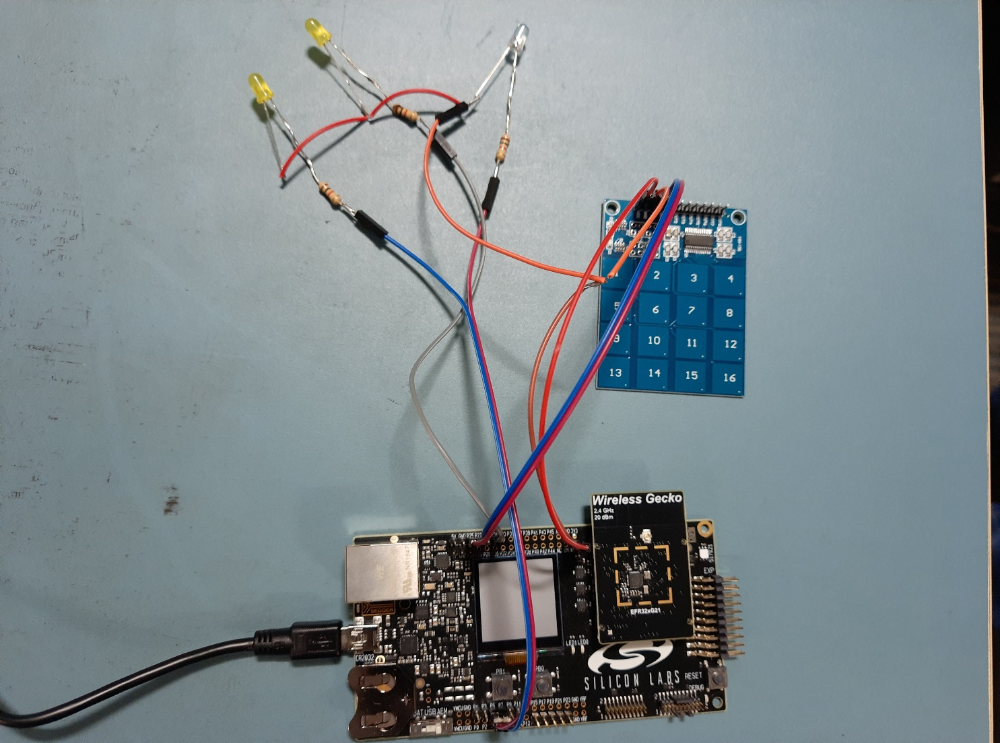

**Figure 6: SLWSTK6006A Interface with TTP229 Keypad Module Image**

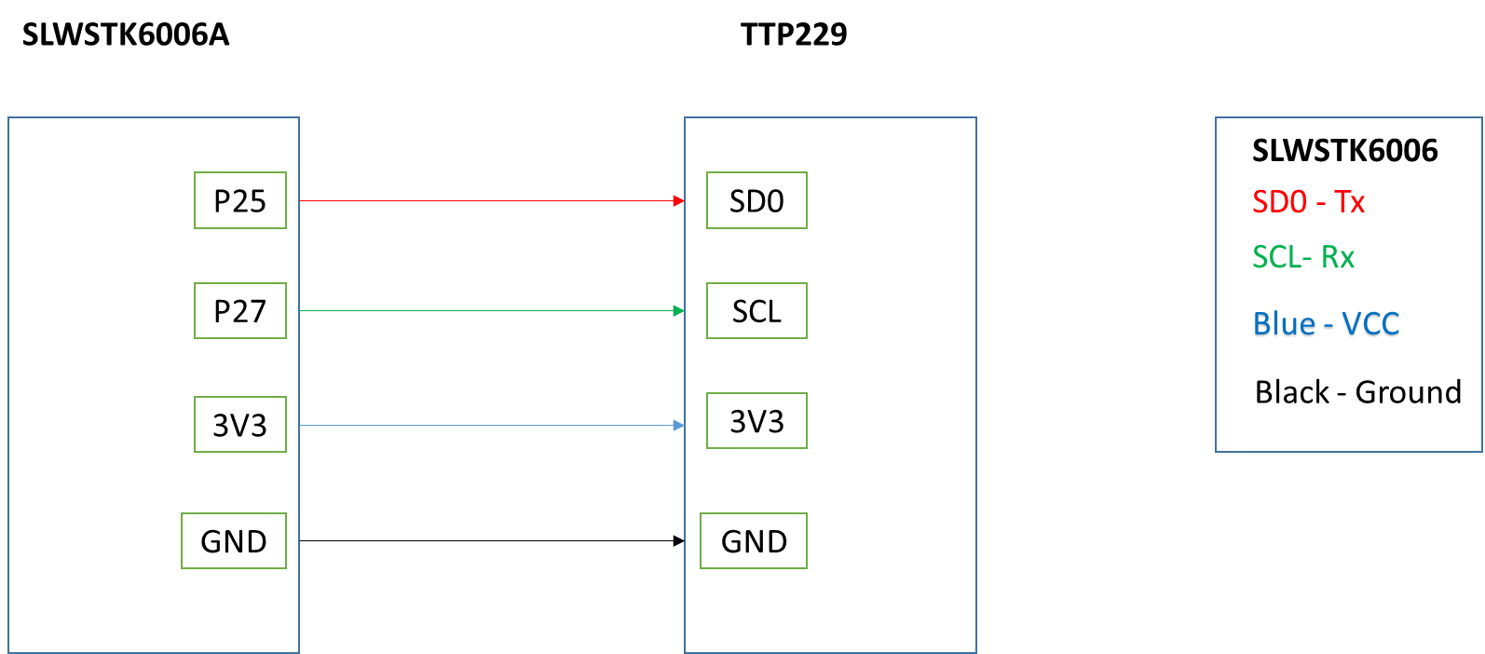

**Figure 7: SLWSTK6006A Interface with TTP229 Keypad Module Pin Out Diagram**

## EFR Set Up with Face Recognition Module

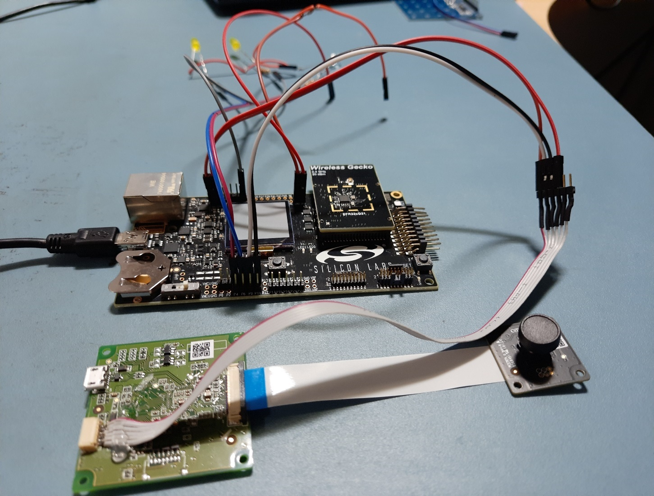

**Figure 8: SLWSTK6006A Interface with Omron B5T Image**

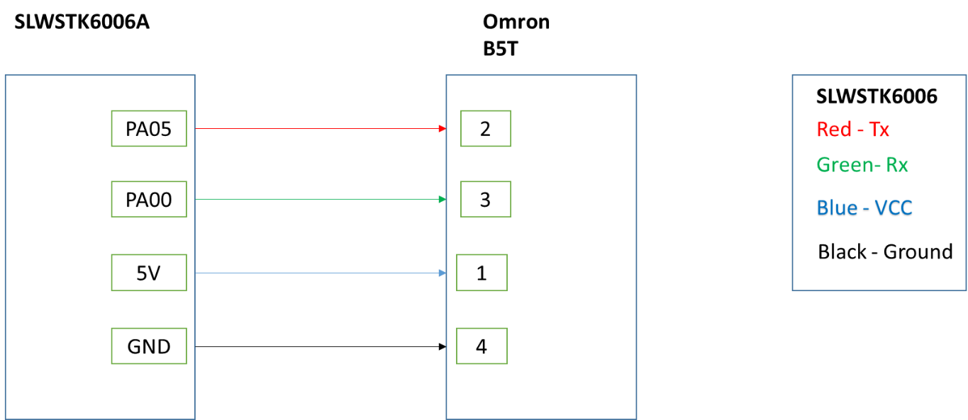

**Figure 9: SLWSTK6006A Interface with Omron B5T Pin Out Diagram**

**Note:** DO NOT connect the USB port and the UART port at the same time; power the camera from a separate USB port to ensure adequate current

## EFR Set Up with LED Module

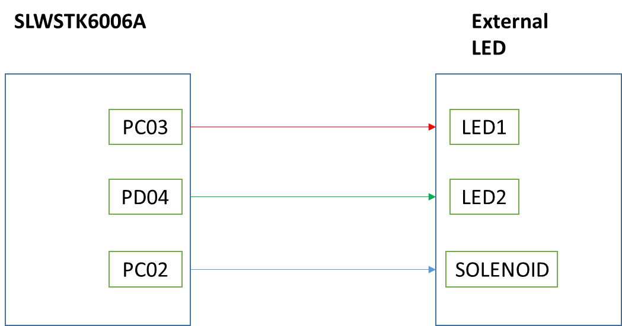

**Figure 10: SLWSTK6006A Interface with External LED Pin Out Diagram**

## Door Lock Zigbee Set Up with Switch

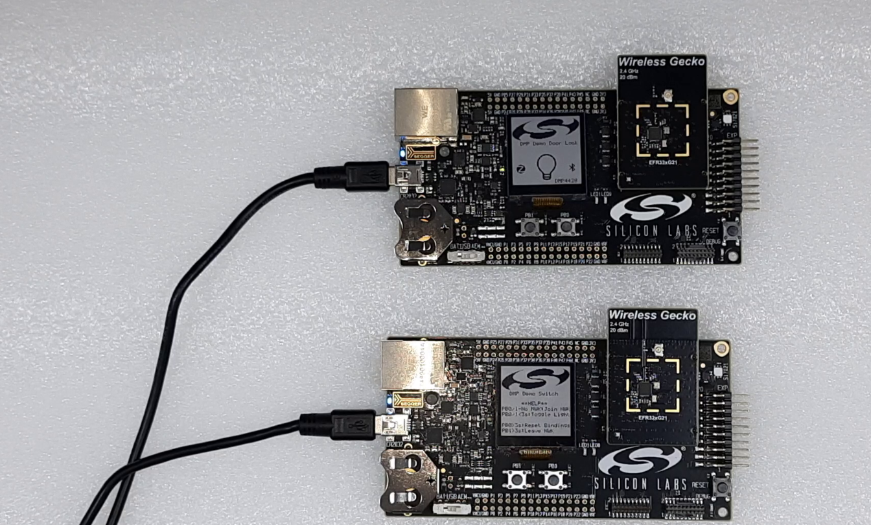

DMP DOOR LOCK

DMP SWITCH

**Figure 11: DMP Door Lock Zigbee Setup with Switch**

As shown in the image required the two efr32mg21 device kit, where one EFR acts as a DMP door lock and another as a DMP switch. DMP door lock system is controlled by the DMP switch. To control the DMP door lock and unlock press the PB0 button from the switch board.

**Note**:- To form the ZigBee network DMP door lock has to be in enrolment mode. Press the PB1 button in the both the board to form the ZigBee network.

# Software required

|  |  |
| --- | --- |
| **Software** | **Version** |
| Simplicity Studio | 4.1.13.6 |
| Gecko SDK | 2.7 |
| IAR license | 8.50.5 |

## Simplicity Studio

### Step for importing workspace in Simplicity Studio is given below

1. **Open Simplicity studio IDE. Click on File->Import**

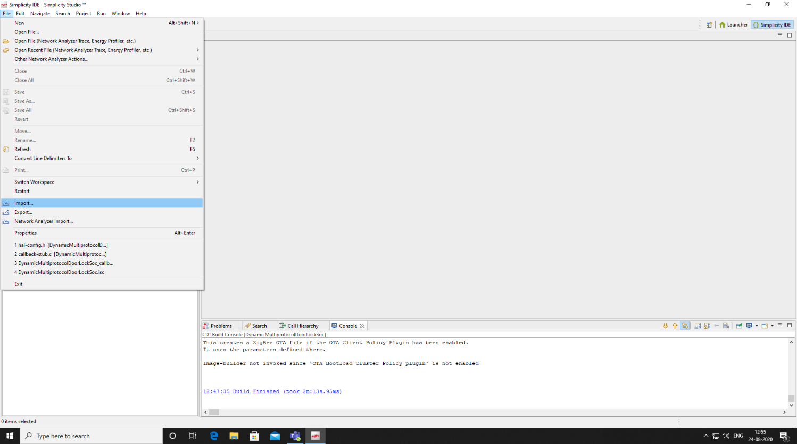

1. **Now browse through the path where your project is located and Click the highlighted option shown in the snapshot below- “Simplicity Studio (.sls)”, and then click Next**

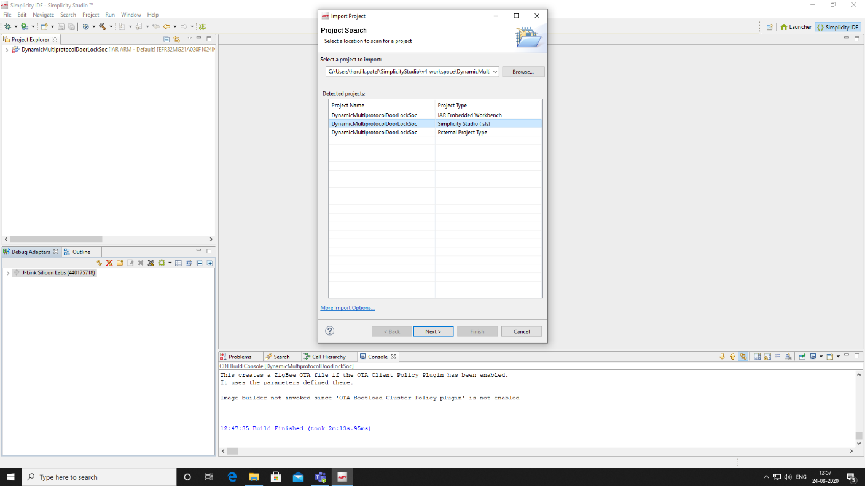

1. **Click “Manage Targets”**
   1. **Verify “IAR ARM” is available and selected under Simplicity Studio -> Targets**
      1. **If unavailable, see the Appendix (Section 8.1) for instructions on downloading an IAR Trial**
   2. **Click OK, then Next**

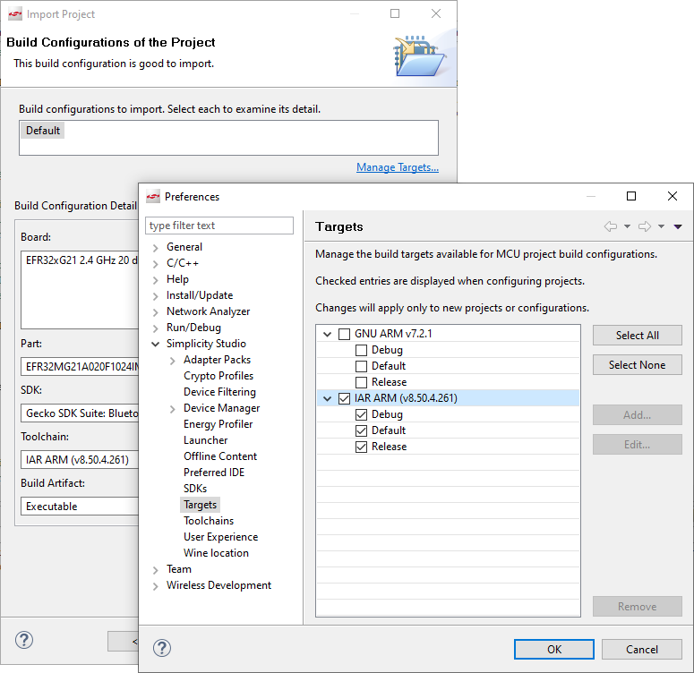

1. **Make sure the project name and location match the name and path of the downloaded example code. If successful, “** **” will appear. Click Finish**

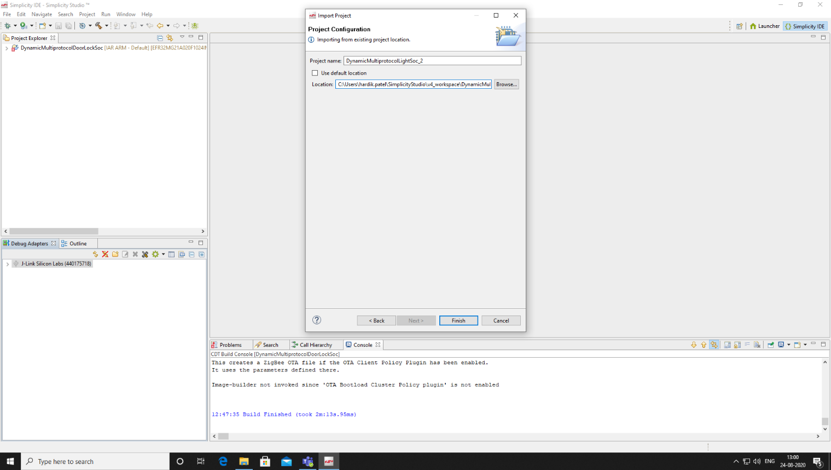

### Steps to update the build path

In the simplicity studio follow below steps,

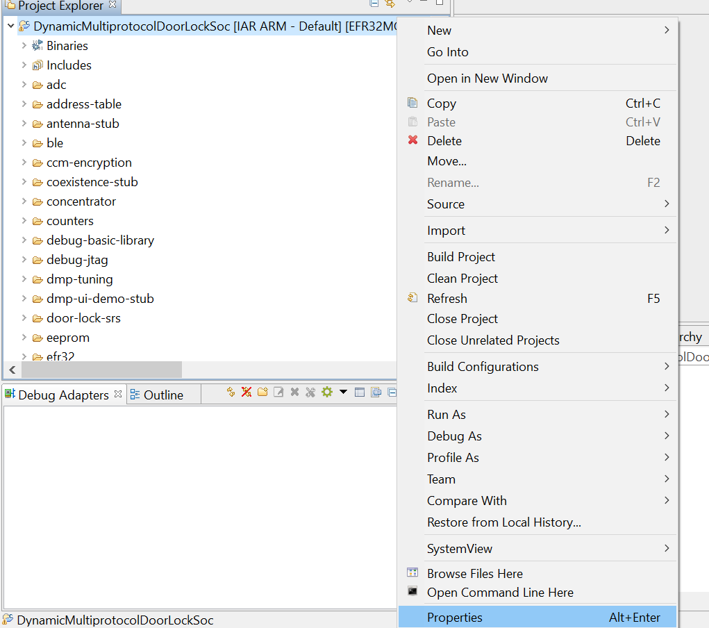

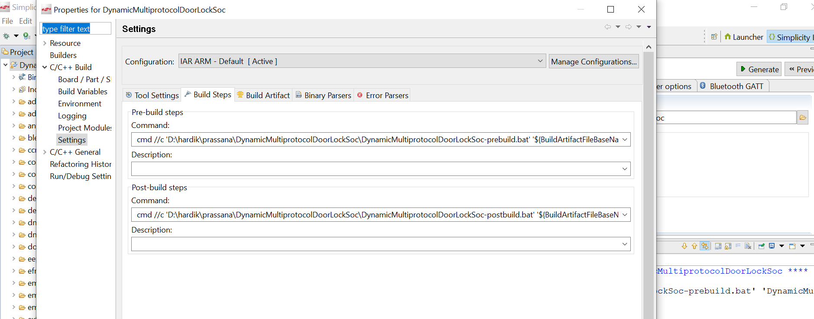

Update your path after cmd://C as shown in the figure

### Steps to build the application

1. **Select the imported project, right click on it and select Build Project option**

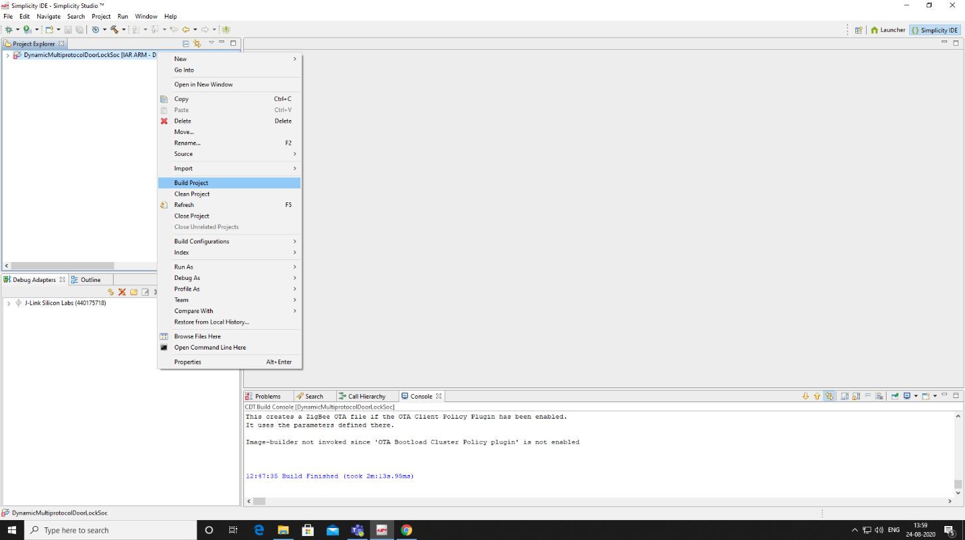

### Steps to upload the application

1. **If not already, plug in the SLWSTK6006A assembly (with radio board installed)**
2. **In the debug adapter window, select JLink Silicon Labs and right click on it**

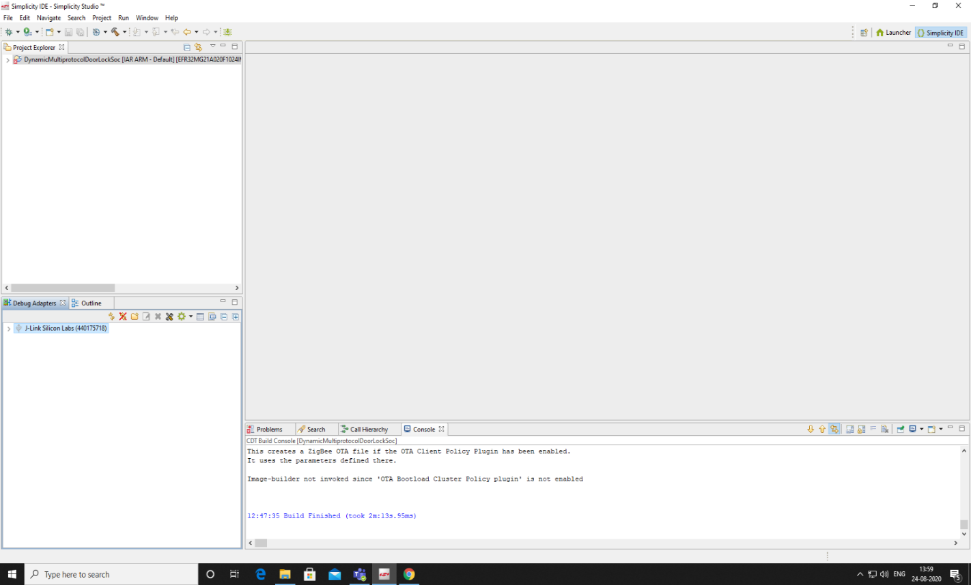

1. **Select Upload Application**

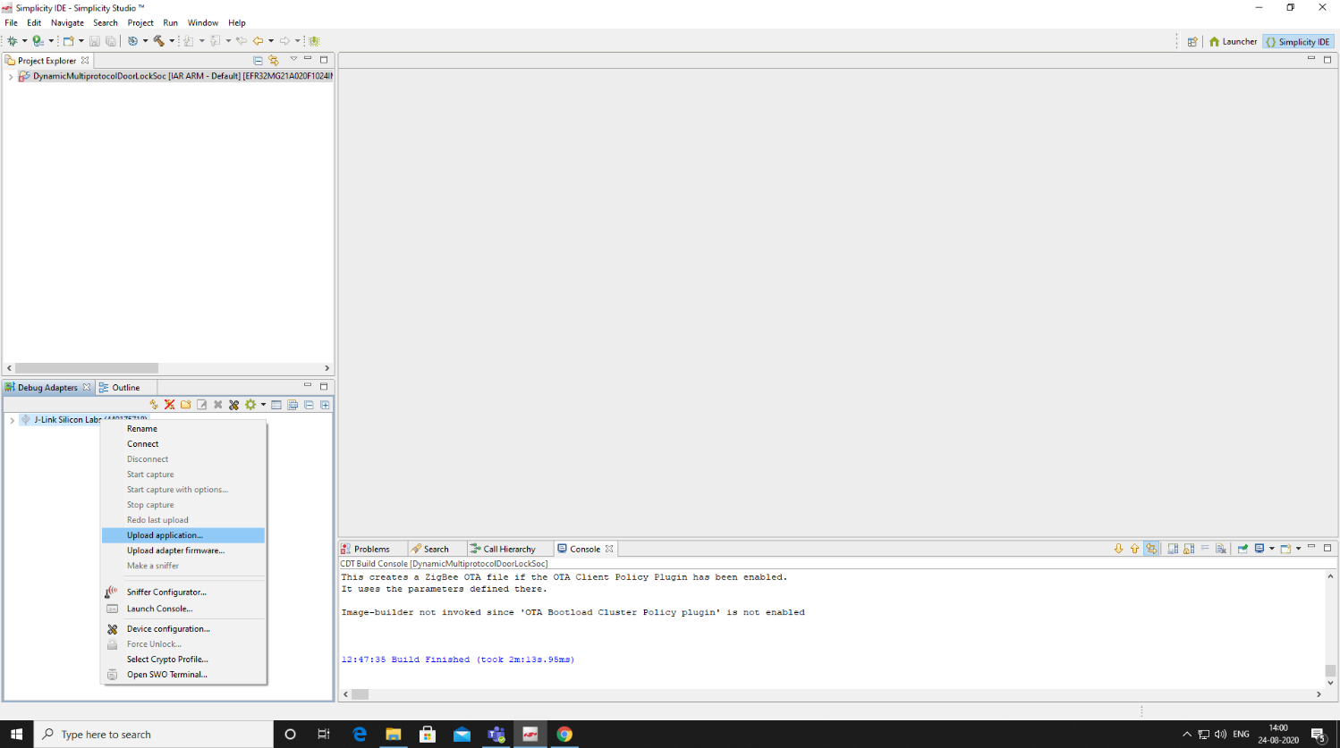

1. **Browse for the Application Image Path**
2. **Navigate to the “IAR ARM - DEFAULT” folder in your project and select the .gbl or hex file**
3. **Select OK, and then OK**

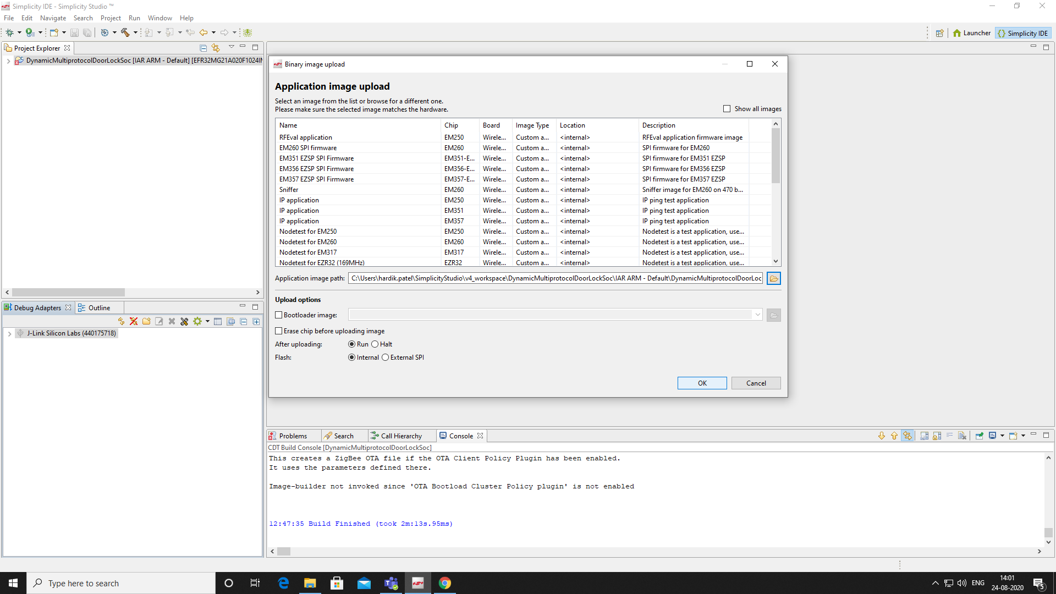

# Operating the Demo

## General Operation



1. LED1 Operation
   1. Button 1 will toggle through operation modes
      1. **Slow Flash**: Single-factor Authentication
      2. **Fast Flash**: Two-Factor Authentication
      3. **Steady-On**: Enrollment Mode
2. LED2 Operation
   1. Button 2 will toggle through operation modes
      1. **Slow Flash**: Keypad Authentication
      2. **Fast Flash**: Fingerprint Authentication
      3. **Steady-On**: Face Authentication
3. When the device is first powered, both LED1 and LED2 will “slow flash”, indicating the device is in single-factor keypad authentication mode. If no LEDs are flashing, the device has gone to sleep, press Button 1 to wake the device
4. Pressing and holding both Button 1 and Button 2 for a few seconds will place the device into enrollment mode; repeating the process will return to authentication mode

## Enrolling an User

Entering enrollment mode will start the enrollment process. Once started, it must be completed to finalize enrollment. Exiting the process or an incomplete enrollment will not store the values in the system.

### Enrolling a Keypad Value

1. Verify LED1 is steady-on, LED2 is slow-flashing
2. Enter a 4-digit code; note the GREEN LED flashes with each keypress
3. Repeat “B” to verify the code
4. Note LED2 changes to fast-flashing, indicating the keypad value step was successful

### Enrolling a Fingerprint

1. Verify LED1 is steady-on, LED2 is fast-flashing
2. Note the fingerprint scanner flashes periodically
3. Place any finger cleanly on the scanner and hold it still
4. Wait for the GREEN LED to flash TWICE (once for the initial scan, once for the verification)
5. Note LED2 changes to steady-on, indicating the fingerprint scanner captured a good fingerprint

### Enrolling a Face

1. Verify LED1 is steady-on, LED2 is steady-on
2. Note that the LED on the camera board is active
3. Position your face 12”-16” from the camera, and is as well-lit as possible
4. Wait for the GREEN LED to flash TWICE (once for the initial scan, once for the verification)
5. Note LED1 and LED2 change to slow-flash, indicating enrollment was successful

## Authenticating a User

### Single-Factor Authentication: Keypad

1. Verify LED1 and LED2 are slow-flashing
2. Enter the 4-digit code from the enrollment step; note the GREEN LED flashes with each keypress
3. If the keycode matches the enrolled value, the GREEN LED and SOLENOID LED will illuminate, indicating the door has been opened
4. The door will automatically lock after 15 seconds

### Single-Factor Authentication: Fingerprint

1. Verify LED1 is slow-flashing, and LED2 is fast-flashing
2. Place the enrolled finger on the scanner
3. If the fingerprint matches the enrolled value, the GREEN LED and SOLENOID LED will illuminate, indicating the door has been opened
4. The door will automatically lock after 15 seconds

### Single-Factor Authentication: Face

1. Verify LED1 is slow-flashing, and LED2 is steady-on
2. Position your face 12”-16” from the camera, and is as well-lit as possible
3. If the facial recognition is successful, the GREEN LED and SOLENOID LED will illuminate, indicating the door has been opened
4. The door will automatically lock after 15 seconds

### Two -Factor Authentication: Keypad + Fingerprint

1. Verify LED1 is fast-flashing, and LED2 is slow-flashing
2. Enter the 4-digit code from the enrollment step; note the GREEN LED flashes with each keypress
3. If the keycode matches the enrolled value, the GREEN LED will illuminate and the fingerprint scanner will flash
4. Place the enrolled finger on the scanner
5. If the fingerprint matches the enrolled value, the GREEN LED and SOLENOID LED will illuminate, indicating the door has been opened
6. The door will automatically lock after 15 seconds

### Two -Factor Authentication: Keypad + Face

1. Verify LED1 and LED2 are fast-flashing
2. Enter the 4-digit code from the enrollment step; note the GREEN LED flashes with each keypress
3. If the keycode matches the enrolled value, the GREEN LED will illuminate and the camera LED will blink off and then back on
4. Position your face 12”-16” from the camera, and is as well-lit as possible
5. If the facial recognition is successful, the GREEN LED and SOLENOID LED will illuminate, indicating the door has been opened
6. The door will automatically lock after 15 seconds

# Known Issues

* Omron B5T face recognition module encounters voltage drop issue when power supply is given from the SLWSTK6006A board.
* Once user update the firmware via OTA, new firmware is not taken from the flash instead it takes the older one.

# Limitations and constraints

# Appendix

## Downloading an IAR Trial License

1. Navigate to “Free Trials” section of the the IAR embedded workbench website

<https://www.iar.com/iar-embedded-workbench/#!?currentTab=free-trials>

1. Click “Download Software”
2. Follow the instructions for obtaining a free full-function 30-day license

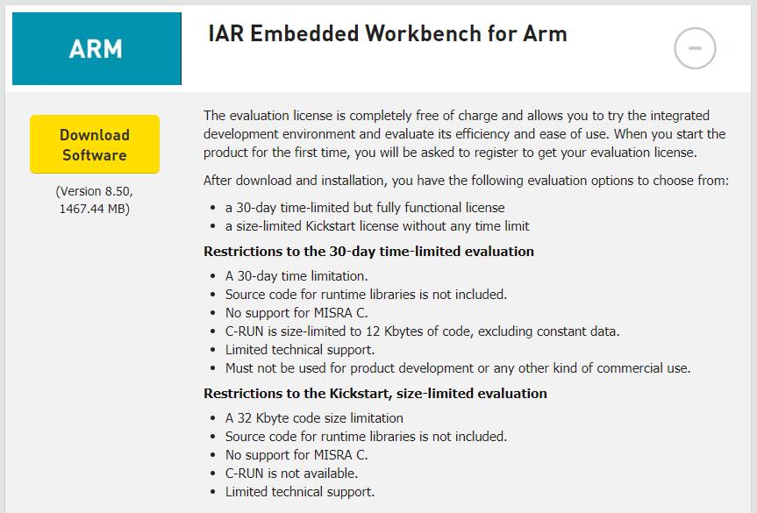

After downloading and installing IAR open the IAR license manager and follow below steps as shown in the figure,

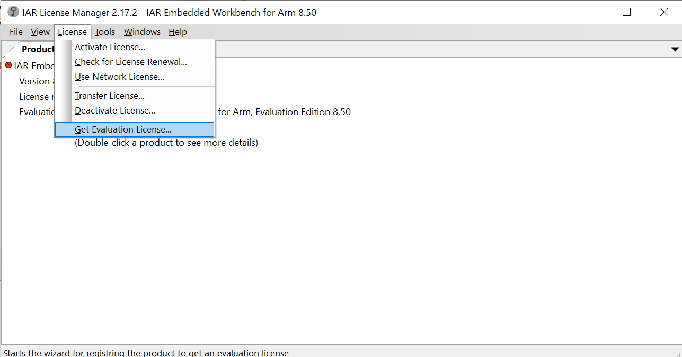

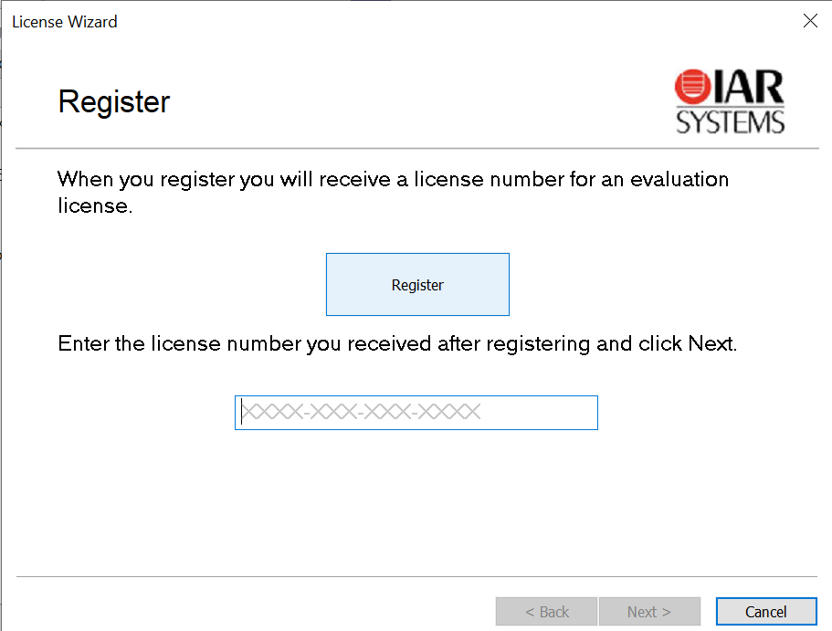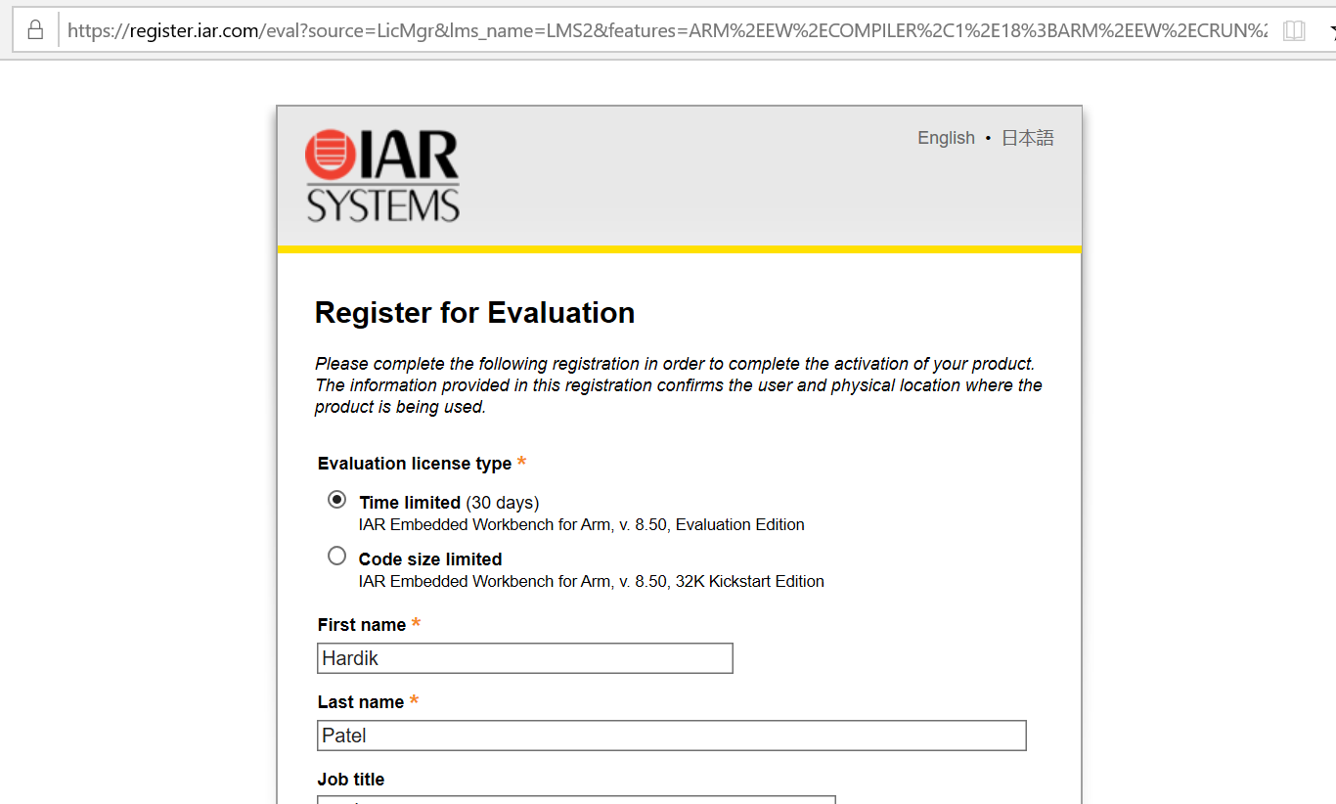

## Datasheets

Below is the link of where datasheet of all the h/w modules are uploaded:

<https://github.com/ArrowElectronicsESC/Silabs_Workswith_DoorLock/tree/master/Datasheet>